Chapter 19, Solution 55.

For the z parameters
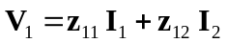 (1)
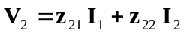 (2)

From (1),
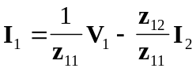 (3)

Substituting (3) into (2) gives
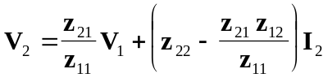
or 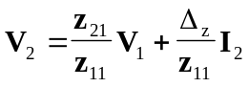 (4)

Comparing (3) and (4) with the following equations
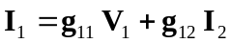
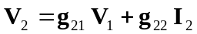

indicates that
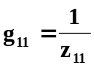, 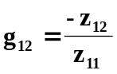, 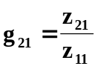, 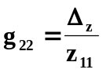
as required.

